Setting up eConsents With Auto-Archiving

REDCap now has the ability to manage Consent form. There are 4 templates in REDCap under the Create New Project. For this example, I will be using the most complex version with multi signatures.

What is e-Consent?
Electronic-Consent (e-Consent) is a platform for consenting patients or research subjects either on site or at home using a computer-based consent form rather than traditional paper documentation. Consent forms can be implemented in a REDCap survey via computer, mobile phone, or tablet. Most importantly, it is highly recommended that you have a discussion with the Institutional Review Board (IRB) if you wish to do e-Consent in REDCap.
How the e-Consent Framework works
The 'Auto-Archiver + e-Consent Framework' survey option adds two things to the typical survey-taking process. 1) Before a participant completes the survey, an extra certification page is added to end of the survey that displays an in-line PDF copy of their survey responses in which they will be asked to confirm that all information in the document is correct. Once they confirm all is correct, the survey will then be marked as complete. The survey will not be considered complete until they fulfill the certification step. 2) Upon completion of the survey, a static copy of their responses in the form of a consent-specific PDF will be stored in the project's File Repository. The consent-specific PDF will have the values of the e-Consent Framework Options inserted at the bottom of each page in the PDF. These values (i.e., name, date of birth, etc.) are added to the PDF as extra documentation of the identity of the person who is consenting.
Why is this called a 'framework'?
The 'e-Consent Framework' is referred to as a 'framework' because enabling this option alone does not provide an e-Consent process but merely provides the general framework or mechanism to allow you to provide e-Consent to patients/subjects. As a survey administrator, you must still create your e-Consent survey and all the questions in it, including name, date of birth, and how you wish to capture the signature. This framework allows you to implement your e-Consent process by providing standardized tools (certification screen + automatic storage of consent form as a 'hard-copy' PDF) while still providing the ability to customize your survey how you wish.
How can the 'signature' process be handled for e-Consent?
Patients/subjects can 'sign' their consents by typing in their name or by utilizing REDCap's 'Signature' field type (i.e., 'wet signature') on the survey. One might also assign PIN numbers to prospective participants to aid in the signature process. Please note that the signature process will NOT be implemented by REDCap automatically, so it is your responsibility as a survey administrator to construct your survey using one of the methods above in order for the signature to get captured appropriately.
What is e-Consent version and type?
e-Consent version and type are both free-form text fields whose value will be inserted at the footer of each page in the PDF. Versioning of a form is a concept whereby you may give it a number or alpha-numeric designation to represent the current version or state of the form. So if the form is modified AFTER data collection begins, then it is recommended that a new version be applied. For example, the first version might simply be '1', and after collecting the consent of a few participants, a question is modified or added, which represents a new version of the form, so you might increment the version to '2' (and so forth). The e-Consent 'type' is optional and is another free-form text field that is just a text label that you might want to display in the PDF footer to signify the type of e-Consent that this survey represents (e.g., pediatric). The type is often used to distinguish between multiple e-Consent forms within a project.

Go to New Project tab to Create a New Project.
Fill in the Title, Purpose and select Use a Temple.
Select Multiple Signature Consent form.
Click the Online Designer Button, then Click the Survey Settings button.

Select Yes to allow participants to download a PDF version of their responses at the end of the survey.

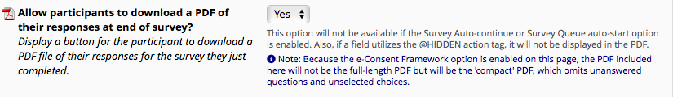

Scroll down to PDF Archiver and fill this section out to meet the needs of your study.

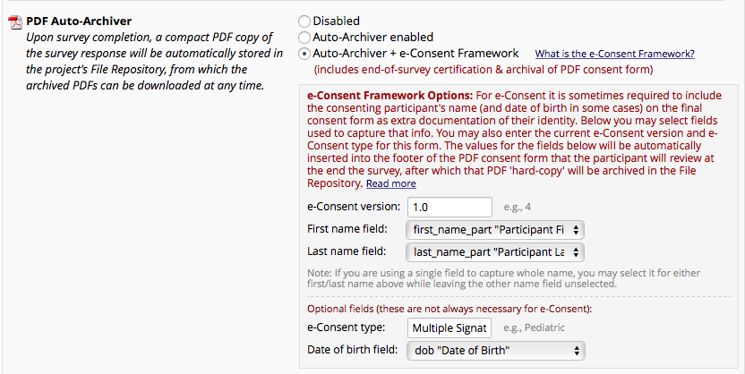

Coordinators will now see the screen below when the consent is consented.
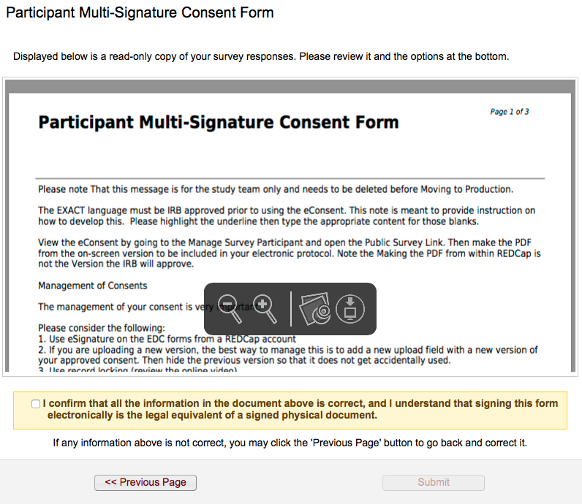

The Participant must confirm that the information is correct and select the check box stating so.
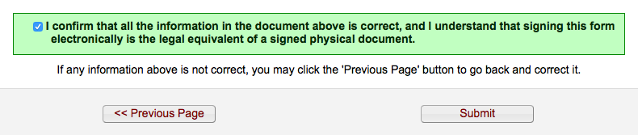

All consents are automatically archived in the File Repository found under the applications section of the REDCap Application.
